For a short video explaining this process and examples go to www.HelpWithPersonalStatement.co.uk/the-process

Use the table below to stimulate ideas. On a post-it note/piece of paper write what it is that you have done. Then underneath what you have learnt from it then finally how it makes you a strong candidate for your chosen course. Choose the box you think it goes best in; they can always be moved around later as you draft your statement.
If there are gaps – there is plenty of time to fill them. An online course, an essay for a competition only takes a day.
GENUINE INTEREST
What have you done outside of your lessons that shows that you are interested in studying the subject further? At least two things.
Examples: essay competitions or lectures. Reading a book is not enough ‘pro-active enough.’

MATURITY
Do you have any evidence of independent learning and managing workload and timelines?
Examples: An extended project/EPQ or CREST Awards/online course.

RELEVANT EXPERIENCE
Have you any experience of this or a similar course like a taster day or work experience of a possible future profession?

A LIFE OUTSIDE OF STUDY
What else do you enjoy?
Not only what do you do but how does it help you balance stress or have you gained evidence of organisational skills?
Examples: helping organising a primary school football tournament shows more relevant skills than playing for the First XI.

Visit our website for videos, examples and more guidance. We are a group of teachers and former admissions tutors with an average of over 20 hours experience. We desperately want there to be a level playing field and make sure that all students can get the advice they need. We will also read through your statement and give you feed back to make sure that it is not luck or lack of support that decides if you go to university.
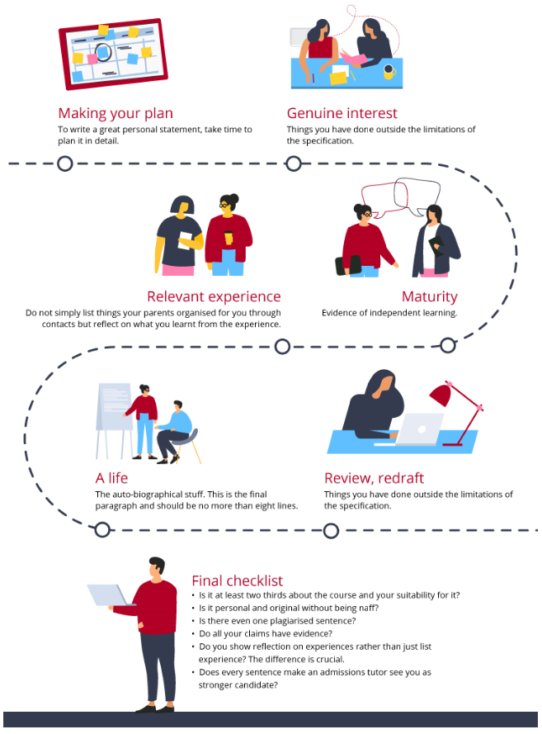
Visit our website for videos, examples and more guidance. We are a group of teachers and former admissions tutors with an average of over 20 hours experience. We desperately want there to be a level playing field and make sure that all students can get the advice they need. We will also read through your statement and give you feed back to make sure that it is not luck or lack of support that decides if you go to university.

